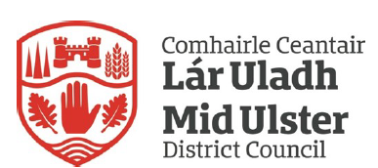

Mid Ulster District Council
Community Planning Update

District Electoral Areas Meetings

